|  |  |
| --- | --- |
| Description: nasa-insig-cl_200px.png  NASA Langley Research Center  Hampton, VA 23681 |  |

Game Changing Development Program

Technical Assessment Periodic Review (TAPR)

Summary Report for the Synthetic Biology (SynBio) Project

Document Control Number: GCDP-02-RPT-21075

Revision: Initial

Document Date: July 07, 2021

Effective Date: September 02, 2021

**Signature Page**

Prepared/Concurred By:

*//Signature on File 09/02/2021*

Rebecca Ernst Date

Review Manager

Game Changing Development Program

*//Signature on File 07/08/2021*

Kevin Kempton Date

Program Element Manager

Game Changing Development Program

Concurred By:

*//Signature on File 08/30/2021*

Amanda Cutright Date

Chief Engineer,

Game Changing Development Program

Approved By:

*//Signature on File 09/02/2021*

Barbara B. Hilton for Gary Meyering Date

Program Manager,

Game Changing Development Program

**Document History Log**

|  |  |  |  |
| --- | --- | --- | --- |
| Status (Baseline or Revision) | Revision | Effective Date | Description of Change |
| Baseline | - | 09/02/2021 | Develop an initial baseline of the Synthetic Biology TAPR Summary Report. |
|  |  |  |  |
|  |  |  |  |
|  |  |  |  |

Table of Contents

[1.0 Purpose 5](#_Toc76632044)

[2.0 Attendance 5](#_Toc76632045)

[3.0 Review Agenda 6](#_Toc76632046)

[4.0 Success Criteria Assessment 7](#_Toc76632047)

[5.0 Findings 7](#_Toc76632048)

[5.1 Key Performance Parameters 8](#_Toc76632049)

[5.2 Technology Readiness Levels 9](#_Toc76632050)

[5.3 Technology Infusion 9](#_Toc76632051)

[5.4 Risk Management 10](#_Toc76632052)

[6.0 Actions (A) and Recommendations (R) 11](#_Toc76632053)

[6.1 Actions 11](#_Toc76632054)

[6.2 Recommendations 11](#_Toc76632055)

[7.0 Review Summary 12](#_Toc76632056)

[8.0 Dissenting Opinions 12](#_Toc76632057)

[Appendix A: Checklist 13](#_Toc76632058)

[Appendix B: Acronyms 14](#_Toc76632059)

Tables and Figures

[Table 1. Voting Members 5](#_Toc76632362)

[Table 2. Ex Officio Members 5](#_Toc76632363)

[Table 3. Success Criteria Assessment 7](#_Toc76632364)

[Table 4. Synthetic Biology Key Performance Parameters 1-3 8](#_Toc76632365)

[Table 5. Synthetic Biology Key Performance Parameters 4-5 8](#_Toc76632366)

[Figure 1. Synthetic Biology Technology Readiness Level 9](#_Toc76632635)

[Figure 2. Synthetic Biology Forward Infusion Plans 10](#_Toc76632636)

[Figure 3. Synthetic Biology Risk Management 10](#_Toc76632637)

# Purpose

The TAPR served as an independent technical review to assess the progress that the Synthetic Biology Project made against its goals and milestones and provide feedback on the future direction of the project, including planned technical activities, milestones, and infusion plan.

The Review Panel assessed and provided comments on the technical accomplishments of the project since the last review, how it advanced the Technology Readiness Level (TRL) of each individual technical capability elements under development, and progress that was made against the project’s Key Performance Parameters (KPPs) and milestones. In addition, the Panel reviewed the technical direction of the project and its infusion plan and provided any recommendations on planned activities or infusion opportunities, paying particular attention to the identification of challenges and/or gaps with respect to current project planning and stakeholder requirements.

# Attendance

**Table 1. Voting Members**

|  |  |  |  |
| --- | --- | --- | --- |
| Voting Members | | | |
| Name | **Affiliation** | **Role** | **Email Address** |
| Kevin Kempton | GCD Program Element Manager (PEM) | Chair |  |
| Gerard Dismukes | Rutgers University | Subject Matter Expert |  |
| Jamie Foster | University of Florida | Subject Matter Expert |  |
| Dave Pletcher | Chief Engineer – Flight Implementation Branch NASA Ames Research Center | Subject Matter Expert |  |

**Table 2. Ex Officio Members**

| Ex Officio Members | | | |
| --- | --- | --- | --- |
| Name | **Affiliation** | **Role** | **Email Address** |
| Jeffrey Sheehy | Office of Chief Engineer | Chief Engineer |  |
| Gerald (Jerry) Sanders | STMD Capability Lead - ISRU | Key Stakeholder |  |
| Mark Thornblom | STMD GCD | Deputy Program Manager, Integration |  |
| Jeffrey Antol | STMD GCD | Lead Systems Engineer |  |

# Review Agenda

| Topic | Presenter |
| --- | --- |
| Introductions & Logistics | Board Chair/Project Manager (PM) |
| TAPR & Evaluation Criteria | GCD PEM |
| Project Overview | PM and Principal Investigator |
| State of the Art and Mission Relevance | Principal Investigator (PI) |
| BioNutrients Goals and Objectives | Principal Investigator |
| CO2-based Manufacturing Goals & Objectives | Principal Investigator |
| Project Milestones and Schedule Overview | PM |
| Technical Accomplishments & Status | PM & Project Team |
| BioNutrients -1 | Project Team |
| BioNutrients -2 and Payload Design Review | Project Team |
| BioNutrients -3 | Project Team |
| CO2-based Manufacturing | Project Team |
| Key Performance Parameters | PM |
| Technology Readiness Level (TRL) & Advancement Degree of Difficulty (AD2) | PM |
| Risks | PM |
| Challenges & Issues | PM |
| Technology Infusion Opportunities/LSII Integration Plan | Principal Investigator |
| Partnerships | Principal Investigator |
| Next Fiscal Year Plans (Technical, Schedule) | PM |
| Education/Public Outreach (EPO) | Principal Investigator |
| Open Discussion/Q&A | PEM |
| Closed Board Discussion | PEM |
| Feedback to Project | PEM |

# Success Criteria Assessment

**Table 3. Success Criteria Assessment**

|  |  |
| --- | --- |
| **Success Criteria** | **Pass/Pass with Comment/Fail** |
| Progress toward   * Goals and objectives * Key Performance Parameters (KPP) | Pass with Comment |
| Advancement of TRL | Pass |
| A technically sound path forward   * Any changes in scope or direction recommended | Pass with Comment |
| Adequate resources | Pass with Comment |
| Identification of technical risks   * Mitigations * Progress to closing risks * New risks recommended to be tracked | Pass |
| Infusion   * Recommendations on infusion opportunities to be considered | Pass with Comment |

# Findings

All board members commented on the value and importance of the work being done in this technology development area. From a TAPR perspective the project has performed well given the challenges associated with the closure of the lab area due to center lockdowns. Although schedules have slipped, the project is expected to meet the goals and objectives listed in the project plan with only minor schedule and cost adjustments.

The project appeared to have adequate resources and personnel with the required expertise in synthetic biology, genomics, and microbial physiology that are well distributed among the team. However, additional expertise in electrochemistry would contribute to consideration of alternate strategies for CO2 conversion to intermediates for cell growth and other outputs **(R-01).**

The engineering designs, fabrication, and testing were generally at a high level for the selected methods.

The process of down selecting the overall path forward for biomanufacturing generated a good deal of discussion since it was not clear whether the alternatives were adequately assessed. **(A-01).**

The team understood the payload hardware design requirements for the various environments (ground transportation, launch vehicle ascent/descent, and International Space Station (ISS) dwell time) must be confirmed. The team appeared confident that the Gen-1 Production Packs would be able to complete all the safety approvals needed to launch on SpX-25 scheduled for May 2022. Design verification of the Gen-1 Production Packs appeared complete. External collaborations were well described and provided results and expertise that strengthened the SynBio project. The design for the Gen-2 Production Packs is simple yet sufficiently complete to meet safety requirements.

## Key Performance Parameters

**BioNutrients:** Due to the ongoing flight experiments on the ISS, the BioNutrient Effort made steady progress on KPP-1 and KPP-2. In addition, lab experiments demonstrated that production packs with two different microorganisms can be grown successfully (KPP-3) which was reflected in the current value given on KPP-3 as “substantiated”.

**Table 4. Synthetic Biology Key Performance Parameters 1-3**

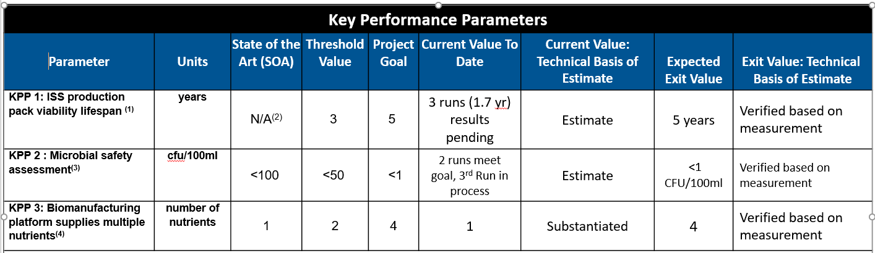

The team produced/acquired transgenic strains of *E. coli* with heterologous genes for synthesis of beta-carotene and zeoxanthin. No primary data was shown on construction and genetic selection **(A-02)**.

The team demonstrated growth rate and biomass yields of carotenoid producing transgenic strains. Strain survivability after ISS flight and over time and following desiccation were well described. This technology advancement will continue with the flight testing of the Gen-1 Production Packs next year.

There was quite a bit of discussion on identifying the amount of nutrients needed versus the amount of nutrients produced in the current versions of the production packs. Although the required amount of nutrients is not known, it may be worth considering a placeholder KPP nutritional requirements to promote the discussions with the key stakeholders **(A-02).**

**Biomanufacturing:** Due to the lack of lab access, progress on the Biomanufacturing KPPs has been limited and still has a long way to go to get to the expected exit values (KPP-4 & KPP-5). KPP-5 basis of estimate was based on published results from external collaborations.

**Table 5. Synthetic Biology Key Performance Parameters 4-5**

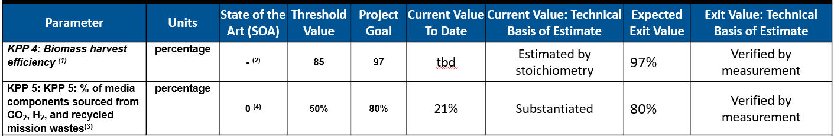

## Technology Readiness Levels

The key milestone for the next TRL advancement of the BioNutrients technology is the flight testing of the Gen-1 production pack on the ISS. Unlike the current Gen-0 production pack, the Gen-1 pack has many of the design features that are expected to be used in an operational system. Launch of the Gen-1 production packs is scheduled for May 2022 and early testing will bring the TRL to a 5.

The Biomanufacturing technology is at a TRL level 3. Testing of the prototype bioreactor lab demonstration unit will raise the TRL to a 4.

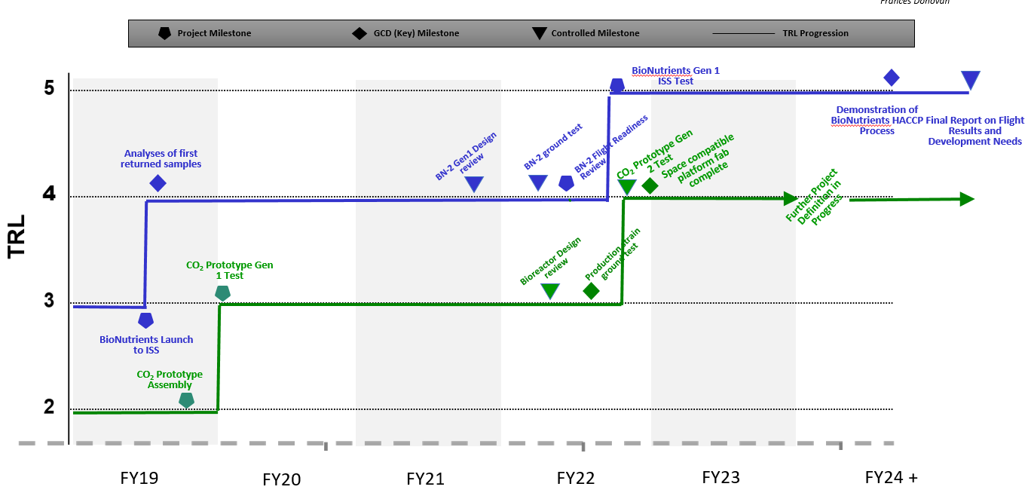

**Figure 1. Synthetic Biology Technology Readiness Level**

## Technology Infusion

John Hogan, the PI for the SynBio project identified several infusion opportunities. Although many opportunities exist for this technology, it is important for the project to begin long term planning for continuation within NASA and begin working formal agreements. (**R-02**)

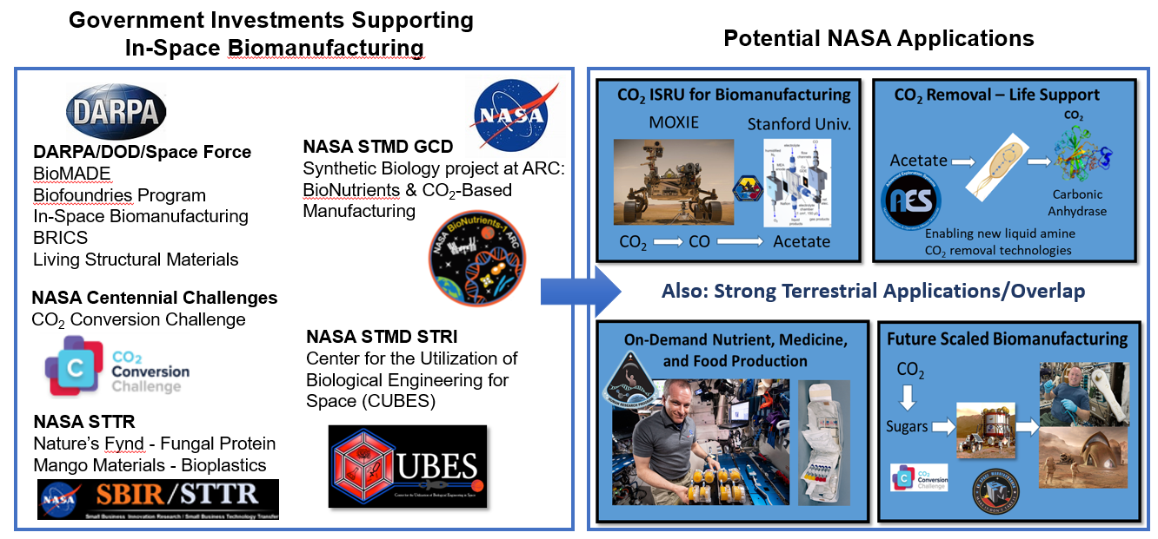

**Figure 2. Synthetic Biology Forward Infusion Plans**

## Risk Management

Risk management was extensively discussed and quantitatively assessed for all phases of the project. This was a noted strength of the project management.

The top risks held steady or decreased in criticality.

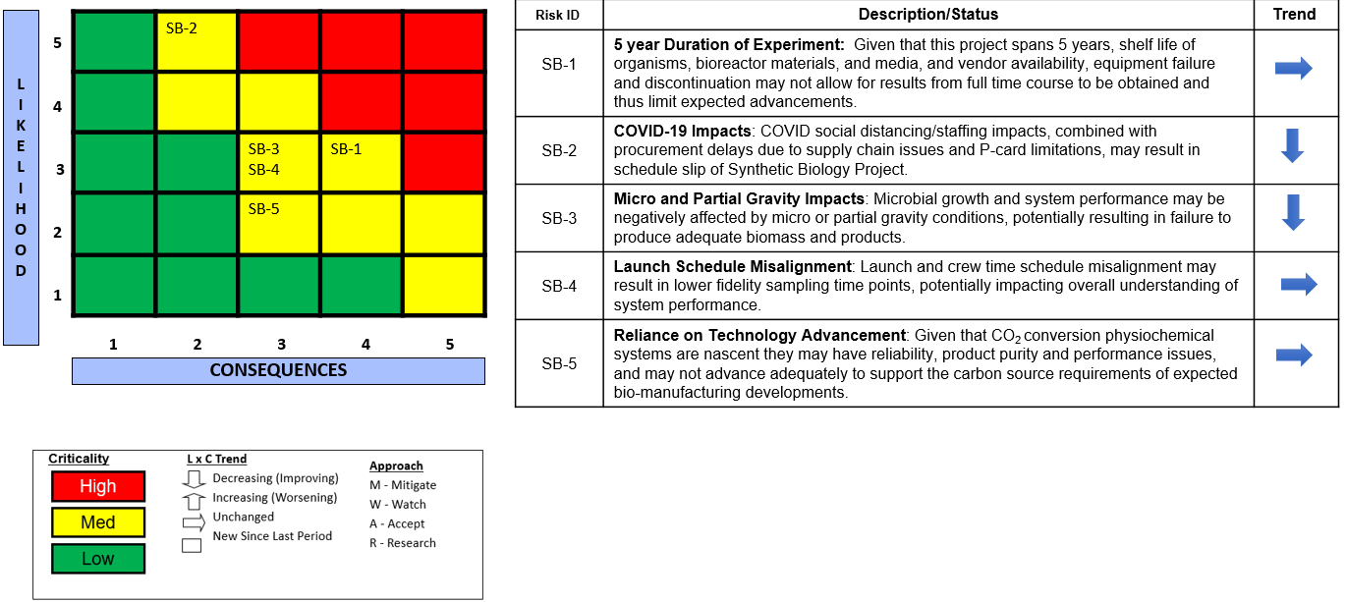

**Figure 3. Synthetic Biology Risk Management**

# Actions (A) and Recommendations (R)

## 6.1 Actions

**SynBioTAPR A-01:** Scope and path forward

**BioNutrients:** Microbial synthesis of human consumable food products from chemical media was the most represented method by the team. Alternate methods of synthesis of chemical media, such as electro-synthesis from CO2, were less developed. The Stanford University external collaboration added this approach. The approach looked promising but may need additional personnel/expertise for full exploration. The team should provide regular updates to the decisions on Slide 94 with more detailed rationale for the path forward.

**Biomanufacturing:** The highlighted bioreactor design that incorporated a cell lysis strategy for recovery of C1 product (formic acid) from the production strain looked economically unfeasible and would benefit from a techno-economic assessment. The team should include economic impact selection criteria in the trade study on Slide 111. The team should also broaden the search for potential use cases for this technology (Potentially with industry or an external ideation challenge).

**SynBioTAPR A-02:** Microbial Bioengineering – The project team provided limited detail on the bio-engineering efforts. The description regarding the requirements and priorities that guided the tailoring of the organisms or how the microorganism would be procured were not well described.

*Example: The discussion of the quantity/concentrations of nutrients that the organisms are expected to produce*. This greatly affected the size of the bioreactors. The team should add more systems engineering rigor to the bioengineering effort or discuss how it is being done. The team indicated they do not have nutritional requirements from the end users so have not specified microorganism production rates. The team should develop current best estimates for nutrient requirements and seek approval from key stakeholders.

**SynBioTAPR A-03:** Production Pack System Description and product requirements – The requirements for the Gen-1 Production Pack appeared to be a combination of procedural and product requirements. The requirements also appeared to be a mixture of Level 2 and Level 3 requirements. In addition, there was not a good system description of the Gen-1 Production Pack that was the subject of the PDR (i.e., what is included in the system and what is considered an external system that it must interface with?). Without a well-defined set of product requirements the system verification will be much more difficult than needed. The team should clearly separate procedural requirements (people requirements) from product requirements. Team members should be assigned as requirement owners based on their technical expertise and support development and verification of their individual Gen-1 Production Pack system requirements. Finally, the team should consider adding a recyclability for the Gen-2 Production Packs since this will offer advantages on the long duration missions targeted by the project.

## 6.2 Recommendations

**SynBioTAPR R-01:** Expertise – Team expertise in chemistry and physics of cellular transport would benefit consideration of biosynthetic processes that determine fluxes of relevance to production scale. The absence of quantitative modelling of predicted fluxes was identified as a potential shortcoming. Additional expertise in electrochemistry would contribute to consideration of alternate strategies for CO2 conversion to intermediates for cell growth and other outputs (CO2 Based Manufacturing).

**SynBioTAPR R-02:** Infusion – Since the SynBio project spans the focus areas of STMD and HEOMD clear agreement at NASA Level 1 who will take ownership of follow-on work once the current project is completed must be ensured. Since the TRL level for BioNutrients will be at a TRL of 5 and the Biomanufacturing effort will be at a TRL level of 4 it may make sense to more cleanly split these technology development efforts. One way to assign ownership could be to generate a formal usage agreement for a specific technology.

**SynBioTAPR R-03:** Industry Engagement – Commercial manufacturing of nutrients is at a high level using both microbial and chemical routes. While selected engagement with industry was briefly discussed, these might be leveraged further in the future. Microbial production of carotenoids is an existing commercial technology that might be considered instead of starting from scratch. It was unclear whether the team has done a TEA (techno-economic assessment) of comparative approaches to carotenoids.

**SynBio TAPR R-04:** KPP verification method – Consider adding a verification method to the KPP tables or identify it in the technical basis of estimate cells.

# Review Summary

The Synthetic Biology project made significant progress towards the goals and milestones outlined in the current work plan. The team adequately demonstrated the feasibility of the proposed BioNutrient and Biomanufacturing projects. Additionally, the work done in this technology development area is of high importance and has the potential to develop important technologies to help maintain crew health for long-duration spaceflight as well as applications for Earth-based uses. The risks associated with the work plan were clearly outlined and efforts by the team to mitigate or reduce potential risks were well articulated.

Despite these advances in the technology development and milestones there were a few areas that have experienced setbacks due to the global pandemic and lack of experienced in electrochemistry that if addressed might help expand or find alternative strategies for CO2 conversion. Additionally, in some aspects of microbial bioengineering the underlying rationale for taxa selection were not well described.

Overall, the project appeared to be on track to address critical issues related to facilitating long-duration space travel with a high likelihood of continued success.

# Formal Dissent

The external review panel was in agreement regarding the major findings of this report and there were no dissenting opinions.

# **Appendix A: Checklist**

By submission of this document, the PEM is certifying the following:

|  |  |
| --- | --- |
| The review presentation is archived on GCD SharePoint | 🗸 |
| The Tech Assessment report is uploaded to GCD SharePoint and is being routed for review and approval |  |
| The Tech Assessment data record file is archived on GCD SharePoint | 🗸 |
| The Project SPAR data form has been updated with the current TRL information | 🗸 |
| The Project SPAR data form has been updated with the current KPP information | 🗸 |

# **Appendix B: Acronyms**

|  |  |
| --- | --- |
| A | Action |
| AD2 | Advancement Degree of Difficulty |
| ARC | Ames Research Center |
| BoE | Basis of Estimate |
| CUBES | Center for Utilization of Biological Engineering in Space |
| DARPA | Defense Advanced Research Projects Agency |
| DoD | Department of Defense |
| EPO | Education Public Outreach |
| GCD | Game Changing Development |
| GEN | Generation |
| HEOMD | Human Exploration and Operations Mission Directorate |
| ISRU | In-Situ Resource Utilization |
| ISS | International Space Station |
| KPP | Key Performance Parameter |
| LSII | Lunar Surface Innovation Initiative |
| PDR | Preliminary Design Review |
| PEM | Program Element Manager |
| PI | Principal Investigator |
| PM | Project Manager |
| R | Recommendation |
| SBIR | Small Business Innovation Research |
| SoA | State of the Art |
| SpX | SpaceX |
| STMD | Space Technology Mission Directorate |
| STTR | Small Business Technology Transfer |
| TAPR | Technical Assessment Periodic Review |
| TEA | Techno-economic Assessment |